Correspondence Concerning Consolidated Biscuits’ Bourbon Creams
From the Archive of Dr Umar Elahi Azam
Manchester, UK
November 2015

RE: Devon Bourbon creams
Important
- Hussain Mamode <mamode.hussain@gmail.com>

- Nov 12 at 7:14 AM
To
- Dr Umar Azam

Message body
Brother Umar,

I hot your email while searching for halal confirmation on the internet. Unfortunately i did not receive the Islamic resources you sent. Vould you please forward them to me?

Brother please find attached the email response i received today. When you get a feedback please keep ne updated.

JaazakAllah Khair.

Hussain Mamode

Devon Bourbon creams
Important
- Hussain Mamode <mamode.hussain@gmail.com>

- Nov 11 at 12:51 AM
To
- dr_umar_azam@yahoo.co.uk

Message body
Assalaamualaikum Wa Rahmatullahi Wa Barakaatuh.

Dear Brother,

I have doubts concerning the “vanilla flavour” in a biscuit named “Bourbon Creams” of the brand “Devon”.

The company manufacturing the biscuits is Consolidated Biscuits co. Ltd.

Here is a link to the product: http://www.cbiscuits.com/Our_Brands/devon

Please help me in knowing if the vanilla flavor used has been extracted with alcohol or if it is Halal.

JazaakAllah Khair brother, May Allah bless you,

Regards,

Hussain Mamode

This email has been checked for viruses by Avast antivirus software.
www.avast.com
From: Dr Umar Azam
To: ameilak@cbiscuits.com
Sent: Wednesday, November 11, 2015 3:00 AM
Subject: FW: Devon Bourbon creams

Dear Sir or Madam
Please see the forwarded email and give me your reply so that I can inform my correspondent.
Kind regards,
Dr Umar
www.dr-umar-azam.com
Sent from my Sony Xperia™ smartphone

Re: Devon Bourbon creams
- Annelyse Bartolo <annelysebartolo@cbiscuits.com>

- Nov 12 at 11:15 AM
To
- Dr Umar Azam

Message body
Dear Dr Umar,

Thanks for your query, kindly note that Mr. Alex Meilak does not work at Consolidated Biscuit any more.

In the meantime we are working on your request and will reply shortly.

Kind Regards,

Annelyse Bartolo

Technical Manager
Consolidated Biscuit Co. Ltd.

Tel. No. +356 21440361
Dir. Line +356 23817138
From: Dr Umar Azam <dr_umar_azam@yahoo.co.uk>
Date: 12/11/2015 10:22 (GMT+04:00)
To: Hussain Mamode <mamode.hussain@gmail.com>
Subject: RE: Devon Bourbon creams
Wa laikum salam, Br Hussain
Thank you for your enquiry which I have forwarded to the Head Office of Consolidated Biscuits in Malta. When I am given a reply by them, I will divulge the information to you; hoping the filling will inshallah be halal so That you can consume them with enjoyment.
Br Hussain, which country are you in? And did you get all those emailed Islamic resources I sent you?
Dr Umar
Sent from my Sony Xperia™ smartphone

RE: Devon Bourbon creams
Important
- Hussain Mamode <mamode.hussain@gmail.com>

- Nov 12 at 12:18 PM
To
- Dr Umar Azam

Message body
I am from Mauritius brother.

Hussain Mamode

Re: Devon Bourbon creams
- Annelyse Bartolo <annelysebartolo@cbiscuits.com>

- Nov 16 at 9:00 AM
To
- Dr Umar Azam
CC
- mamode.hussain@gmail.com

- vdeguara@cbiscuits.com

Message body
Dear Dr. Umar,

Kindly note that the vanilla flavours used in the Devon Bourbon Creams are both Halal.

Please refer to the documents attached.

Kind Regards,

Annelyse Bartolo

Technical Manager
Consolidated Biscuit Co. Ltd.

Tel. No. +356 21440361
Dir. Line +356 23817138

INTERNATIONAL FLAVORS AND FRAGRANCES INC.
IFF Code/Customer Code: 15811902 / 15811902

Description: VANILLA FLAVOR LIQUID

HALAL STATEMENT

We herewith declare that this product conforms to the following requirements:

- The product does not contain ingredients of animal origin that are not permitted according to the religious requirements.

- The product does not contain ethanol that is not permitted according to the religious requirements.

- The equipment used for manufacturing this material is not used for the manufacture of other products that are not permitted according to the religious requirements, or has been adequately cleaned to prevent contamination by such non-permitted products.

This is a computer generated document and is therefore not signed.

16 - Nov - 2015

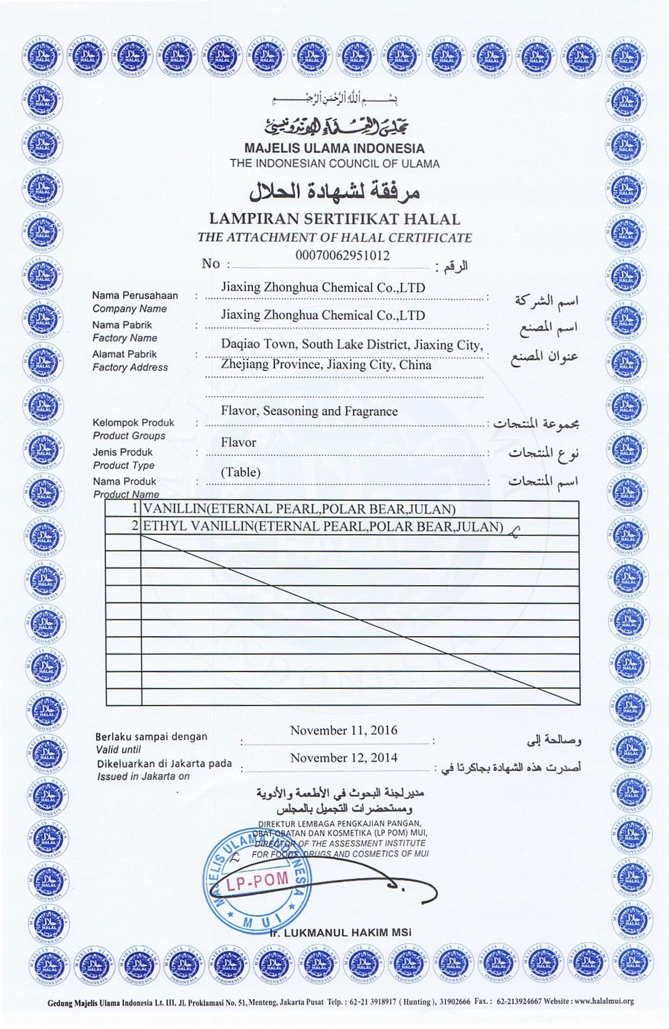

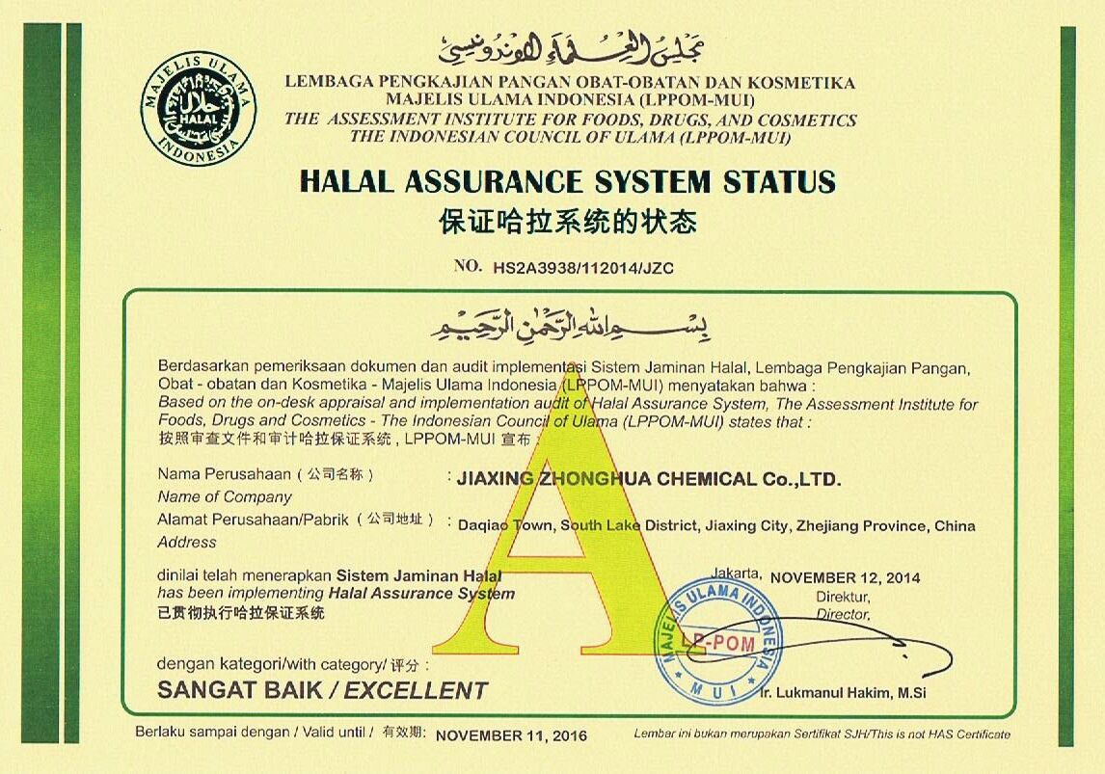
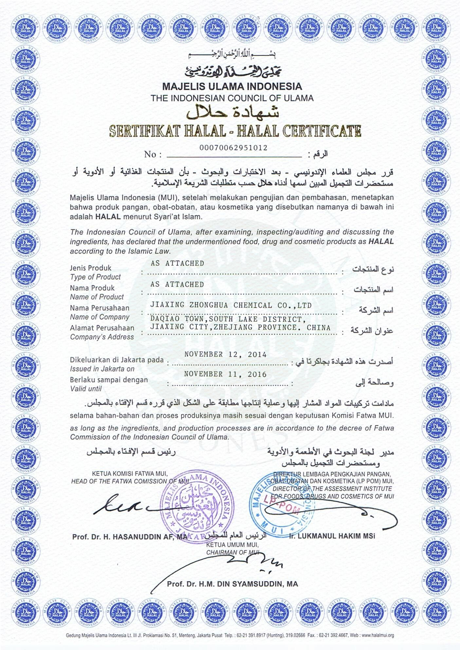

Re: Devon Bourbon creams
Important
- Hussain Mamode <mamode.hussain@gmail.com>

- Nov 16 at 10:33 AM
To
- Annelyse Bartolo

- Dr Umar Azam
CC
- vdeguara@cbiscuits.com

Message body

Dear Madam,

Thank you very much for your confirmation.

Best regards,

Hussain Mamode

Re: Devon Bourbon creams
- Dr Umar Azam <dr_umar_azam@yahoo.co.uk>

- Nov 16 at 1:11 PM
To
- Annelyse Bartolo
CC
- mamode.hussain@gmail.com

- vdeguara@cbiscuits.com

Message body
Dear Annelyse Bartolo,
Thanks so much for your confirmation.
And now that we know, Br Mamode, please do enjoy the biscuits yourself and be happy to recommend them to other friends, relatives and contacts in your locality.
Kind regards,
Dr Umar
Sent from my Sony Xperia™ smartphone

Re: Devon Bourbon creams
- Dr Umar Azam <dr_umar_azam@yahoo.co.uk>

- Nov 16 at 1:24 PM
To
- Annelyse Bartolo

- Hussain Mamode
CC
- vdeguara@cbiscuits.com

Message body
PS
That locality being Mauritius and the biscuits being imported from Malta (I myself being in the UK and residing n Manchester have not seen Consolidated Biscuits' products in my own city but a/guess hat outlets in London might stock the Brand).
Sent from my Sony Xperia™ smartphone

