MIRACLE TANGERINE PHOTOGRAPHS – 17/10/14
Exclusive to Dr Umar Azam
Manchester, UK

This tangerine [which was in the same punnet as the one of 15/10/14 and likewise bought from Manchester Superstore, Stockport Road, M13 UK on Saturday 11 October 2014] is different from the one of 15/10/14 because, on this particular one, the Arabic letters of the Name of Allah S.W.T.

[Please scroll down to the next page]

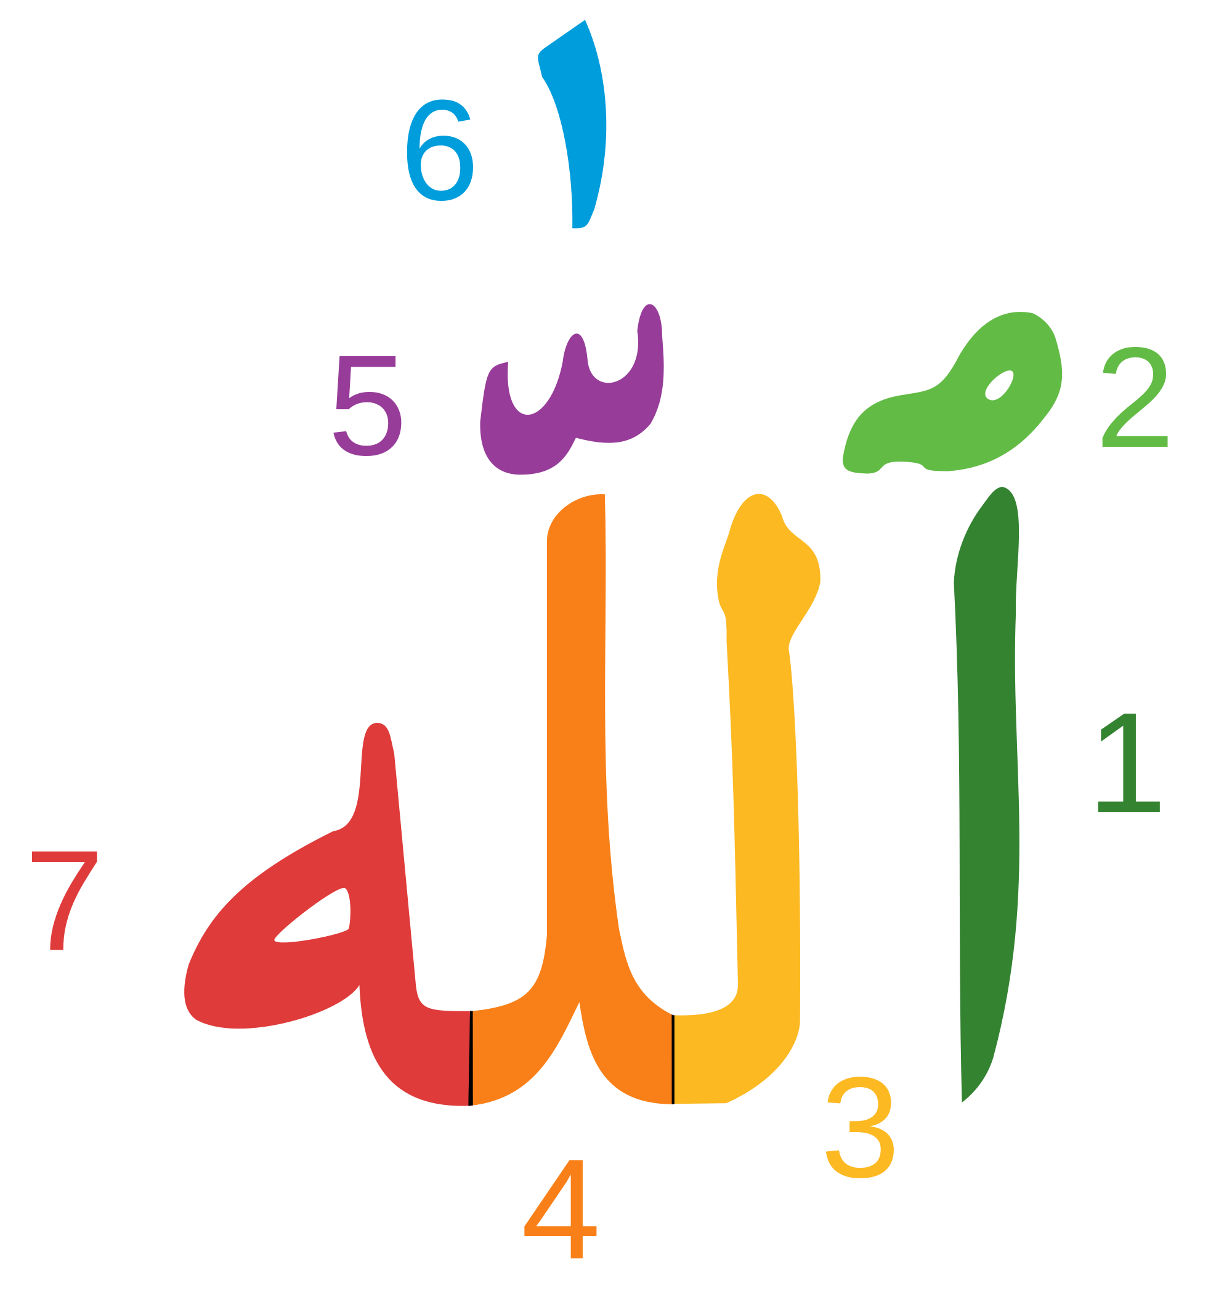are transposed. The letter ‘Alif’ 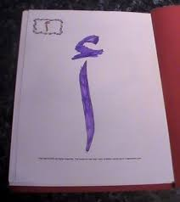is on the left hand side of the rest of the word, instead of on the right hand side;

The shad [5, 6 in the graphic of the Name of Allah, above] is also a little jumbled but it is clearly visible at the top of the main group of letters.

[Please scroll down to the next page]
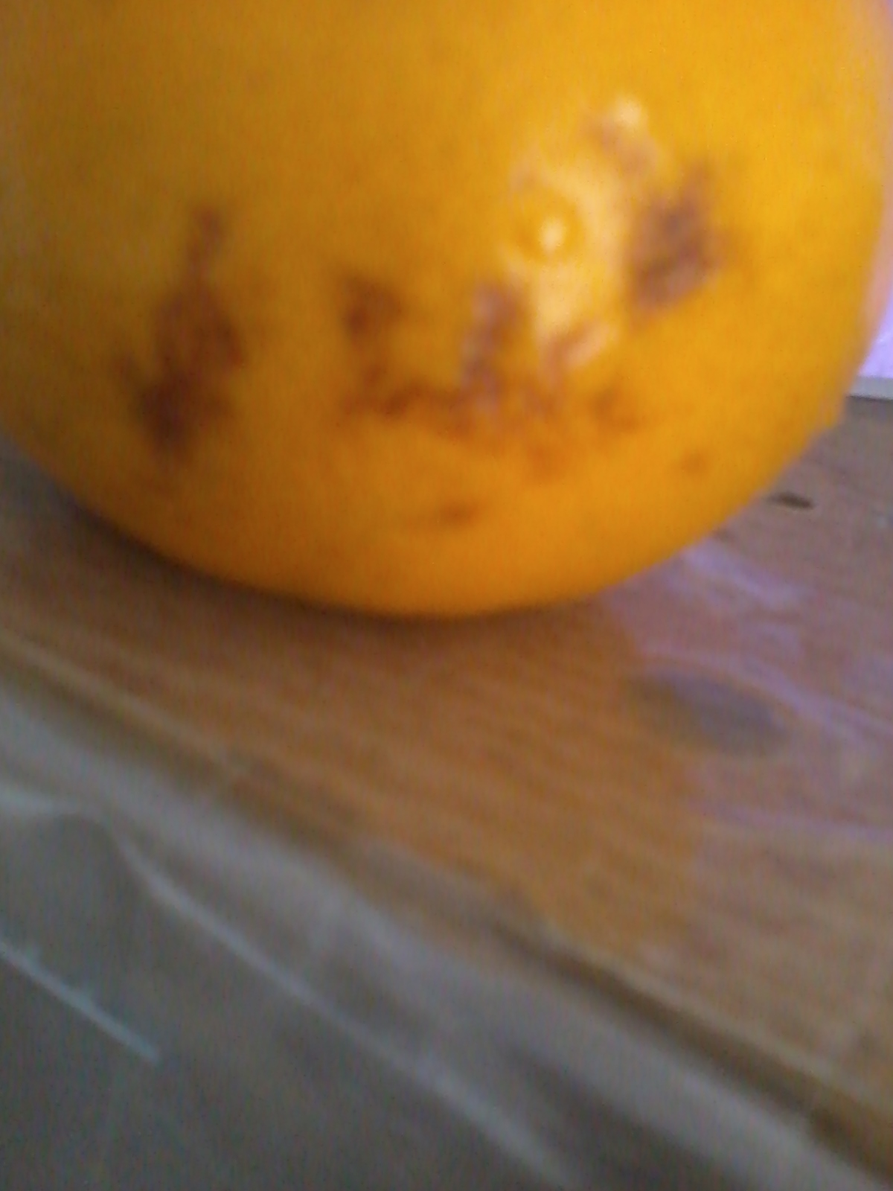
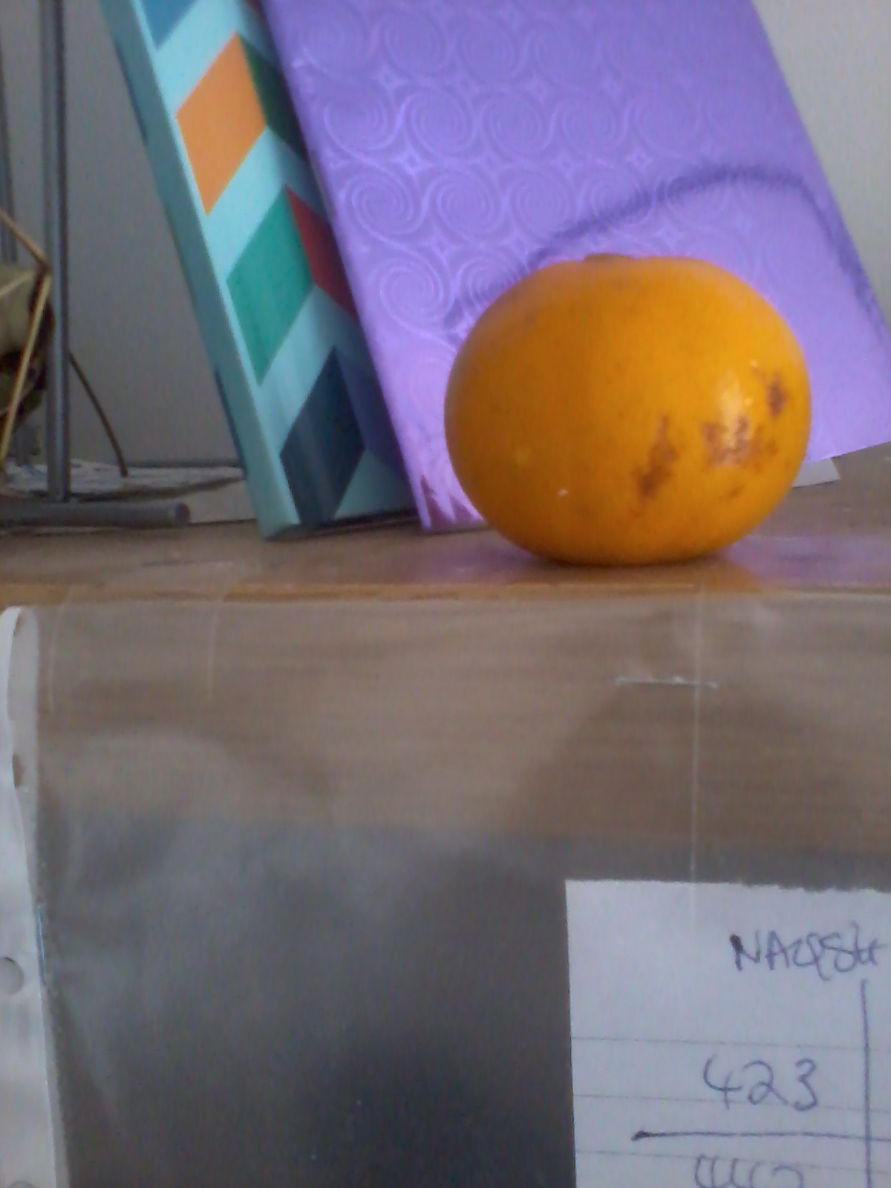
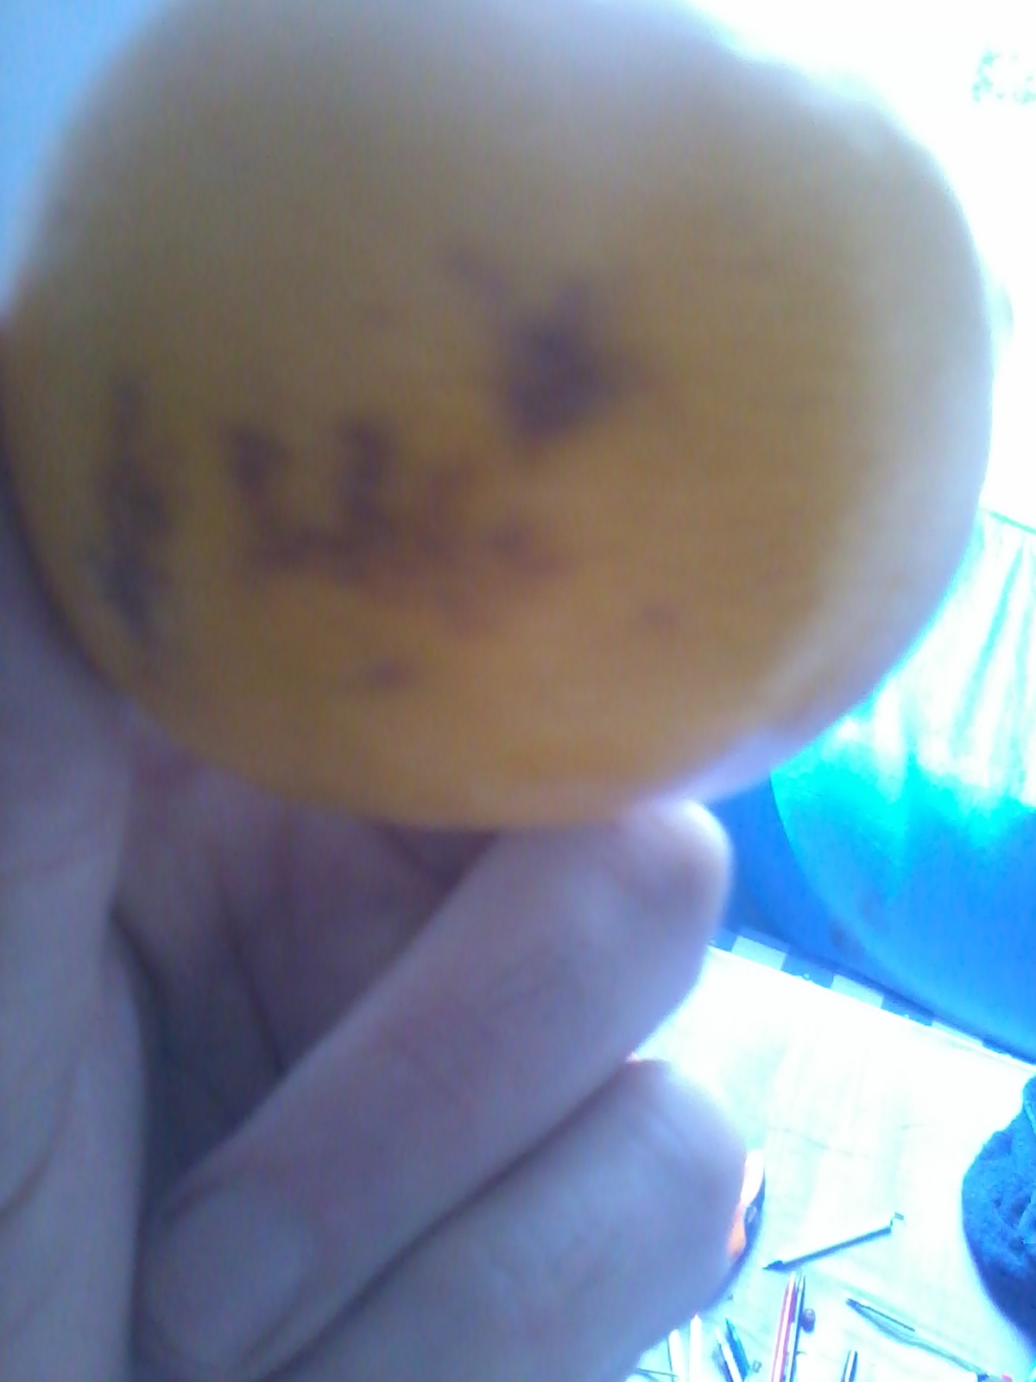
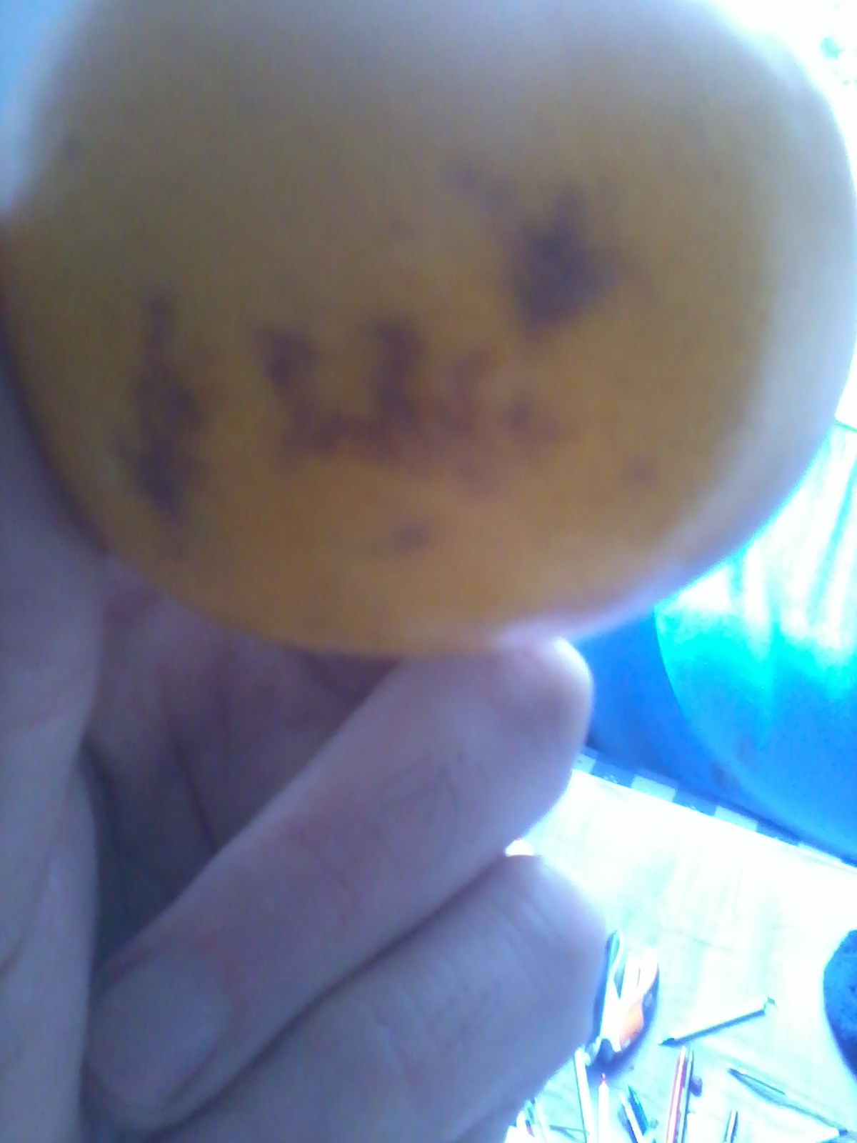
Allah’s Name may also be made out in an inner segment of the tangerine [see the top one of the two sections below]:

[Please scroll down to the next page]

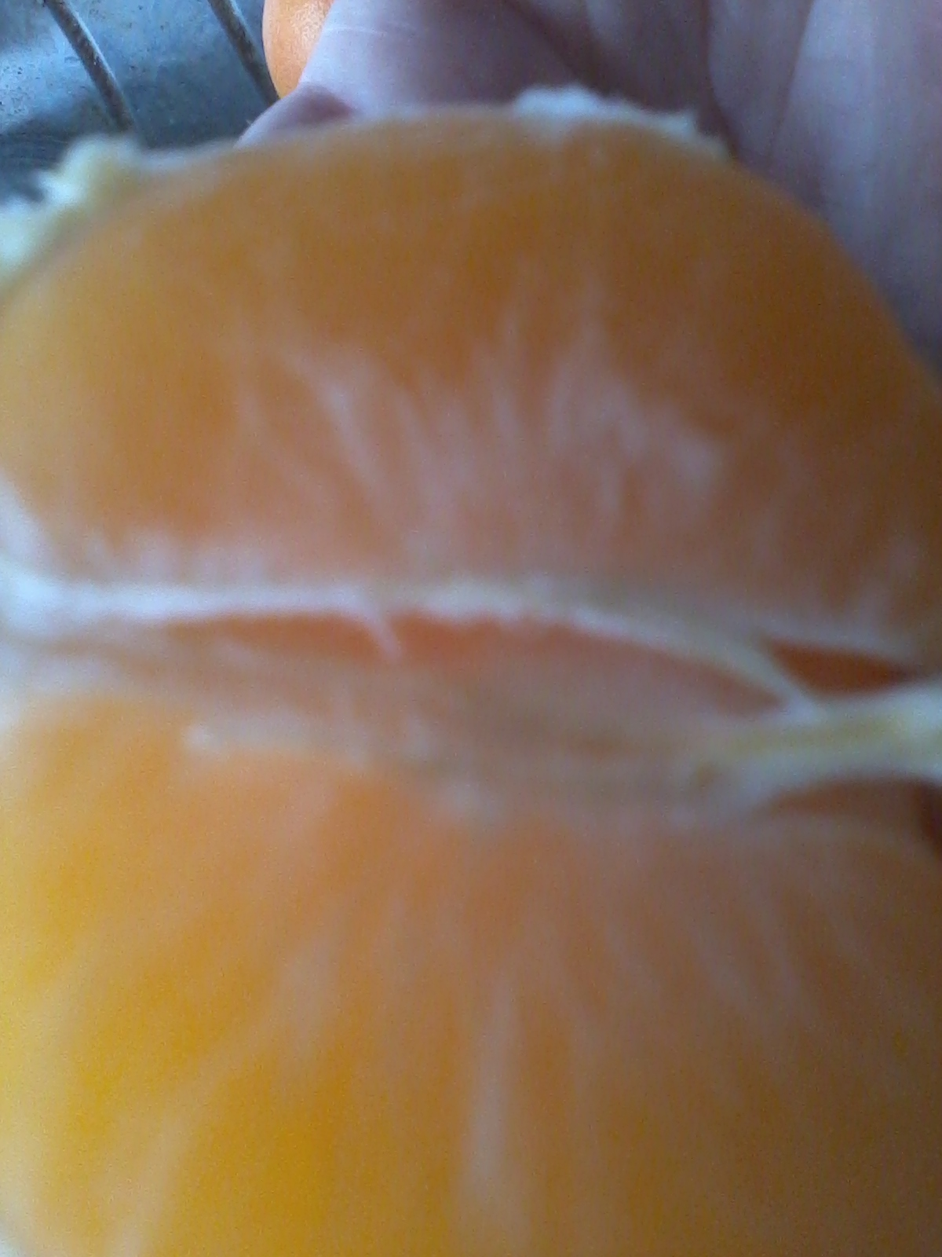

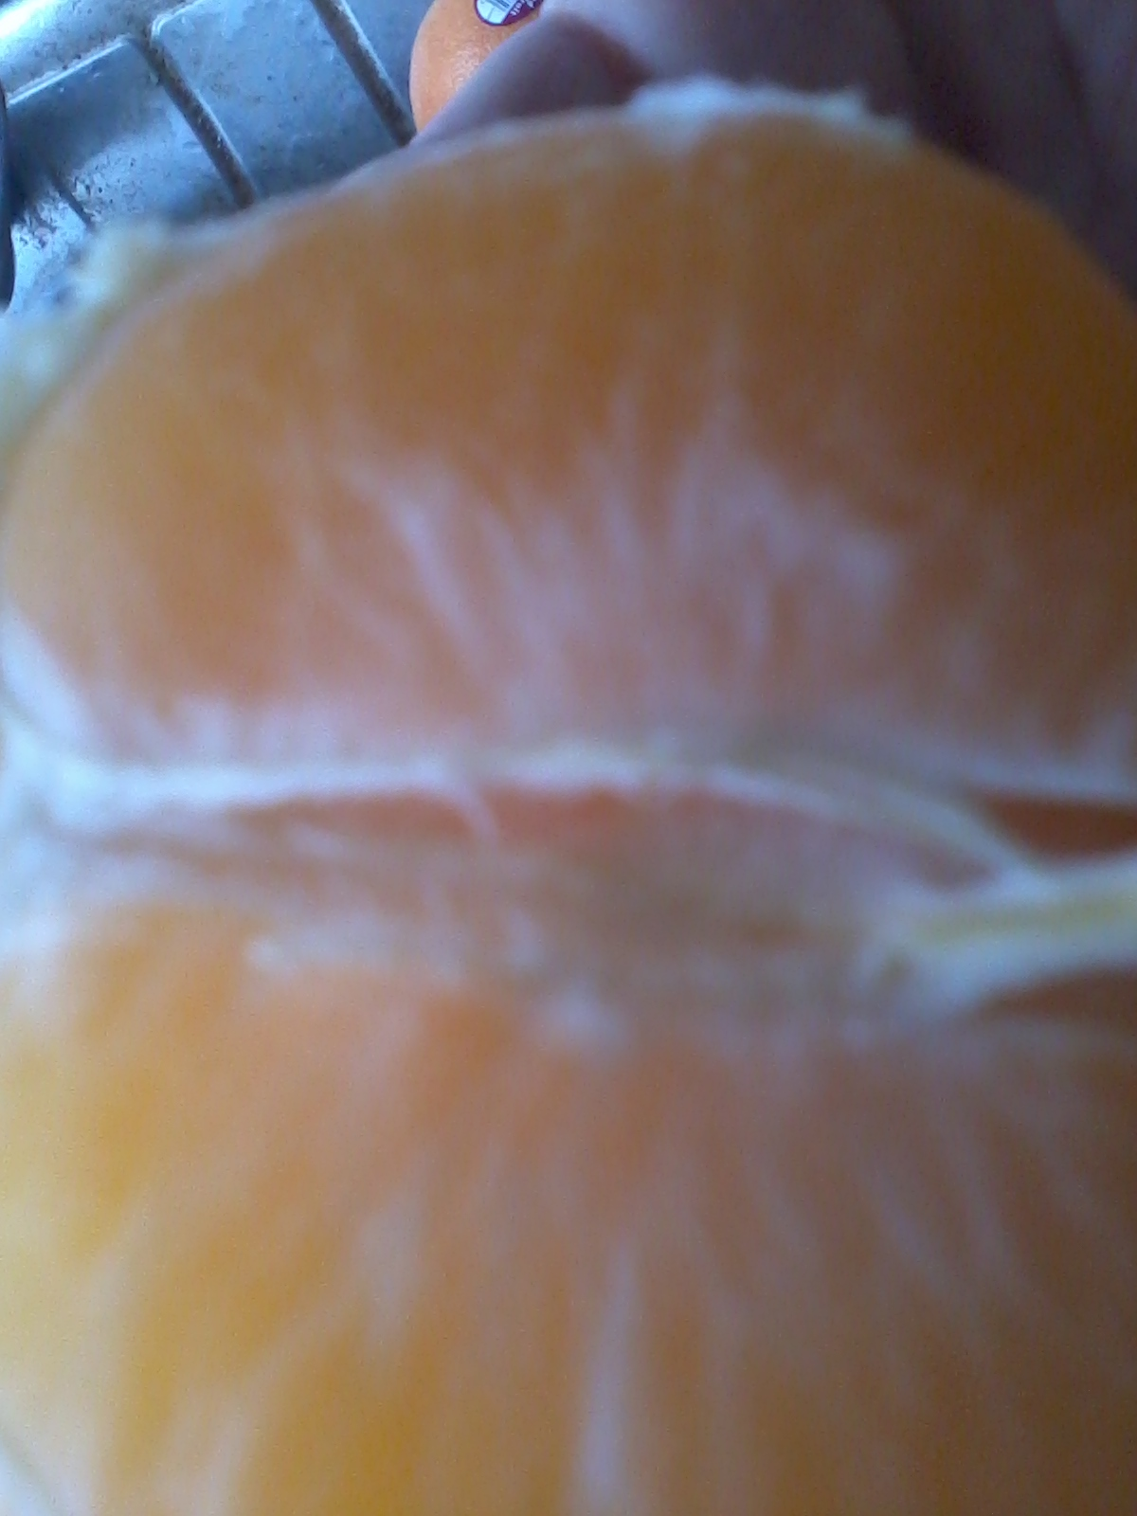
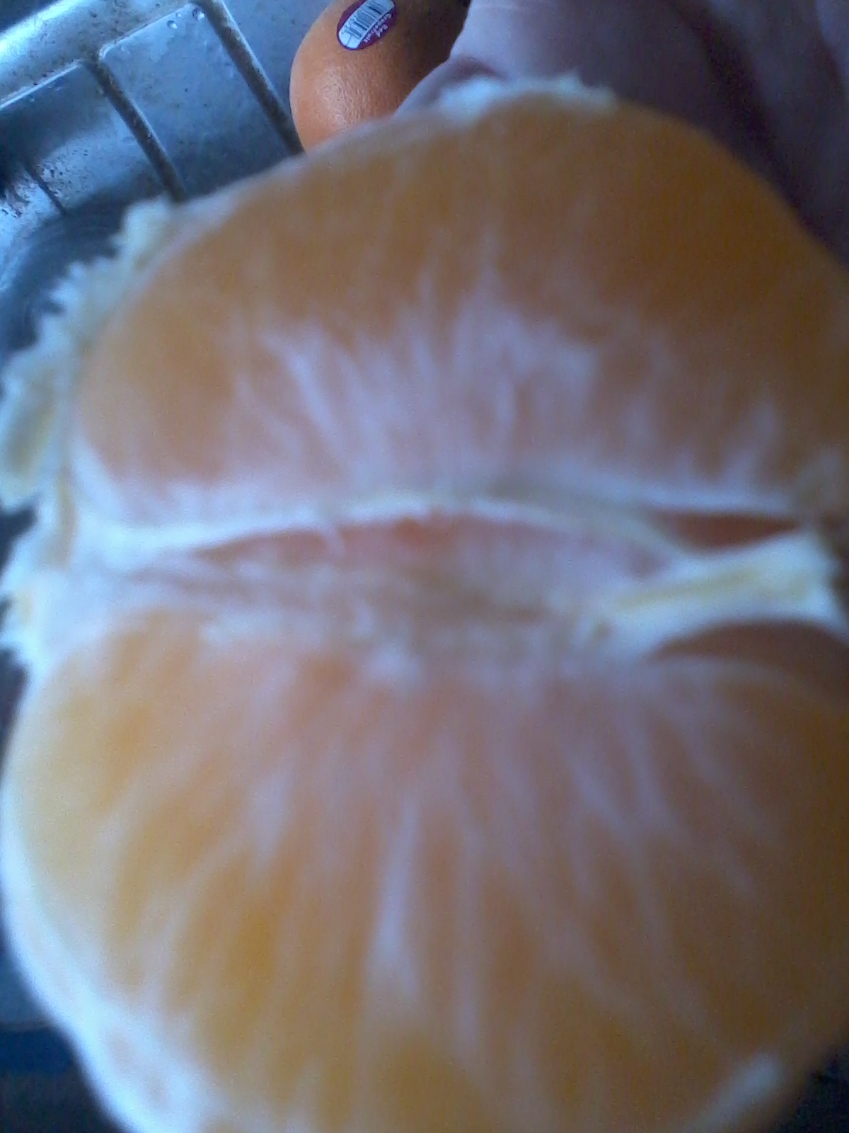

Please click the link below to see the colour scan with an indication to highlight the Name of Allah S.W.T. inside the tangerine:

http://dr-umar-azam-blog.weebly.com/uploads/3/1/8/2/31826375/201410172221.pdf

