THE EXCLUSIVE ISLAMIC MIRACLE PHOTOGRAPHS OF DR UMAR ELAHI AZAM: THE MIRACLE TANGERINE OF FRIDAY 24 OCTOBER 2014
MANCHESTER, UK

I WAS FORTUNATE ENOUGH TO DISCOVER THE NAME OF ALLAH MOST HIGH IN ARABIC IN 3 SEGMENTS OF THE SAME TANGERINE! AND ONE SEGMENT IN PARTICULAR HAD THE NAME OF ALLAH ON BOTH ITS SIDES, MAKING A TOTAL OF 4 PHOTOGRAPHS!
(ALTHOUGH THE NAME OF ALLAH WAS DISCOVERED ON 24/10/14, THE TANGERINES WERE BOUGHT LOOSE [BEING SOLD LOOSE PER KG] ON WEDNESDAY 22 OCTOBER 2014 FROM APPNA EXOTIC FOODSTORE, MITRE ST, M13 UK)

THE PHOTOGRAPHS

SEGMENT ONE, SIDE A
ALLAH’S NAME IS AT THE TOP-CENTRE OF THE SEGMENT
[FOR PHOTOGRAPH, PLEASE SCROLL DOWN TO THE NEXT PAGE]

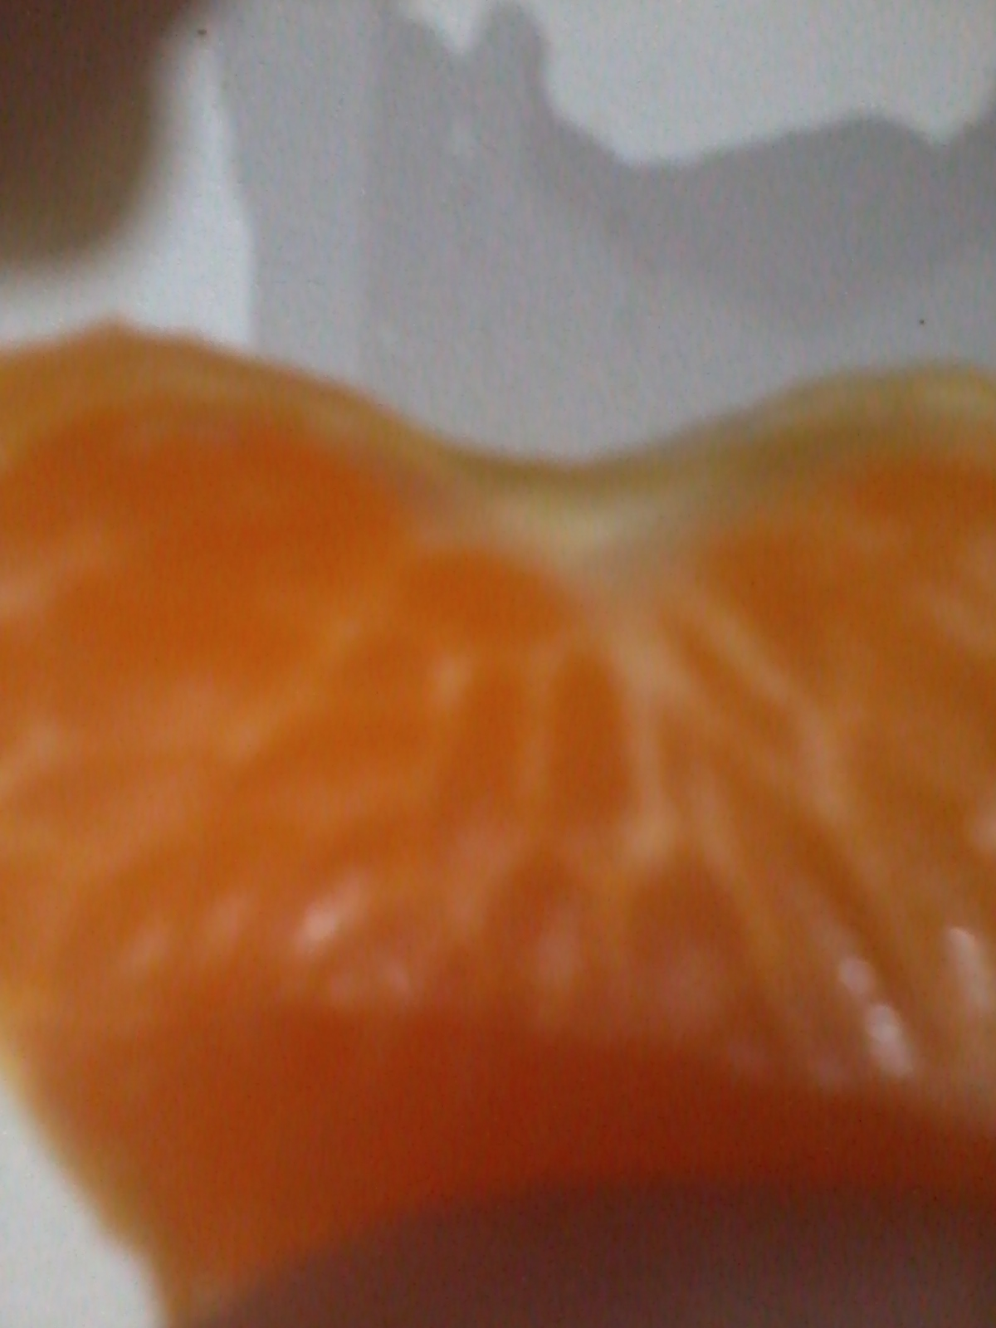
SEGMENT ONE, SIDE B
ALLAH’S NAME IS AT THE BOTTOM-MIDDLE OF THE SEGMENT
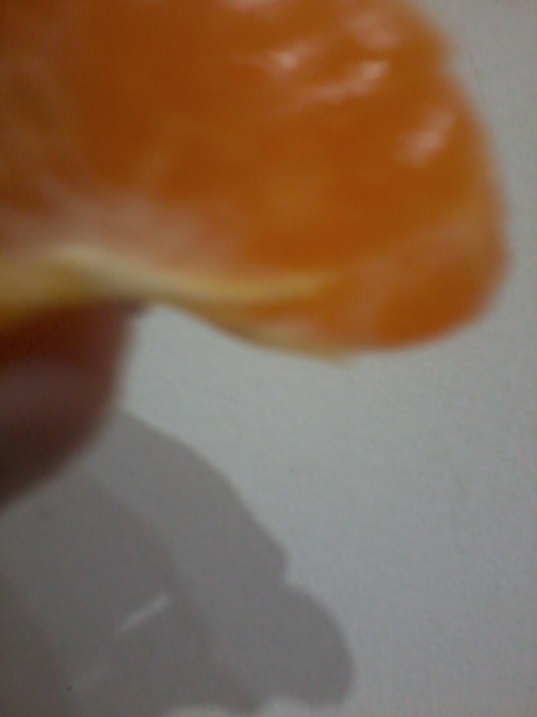
SEGMENT TWO
ALLAH’S NAME IS AT THE BOTTOM-LEFT OF THE SEGMENT

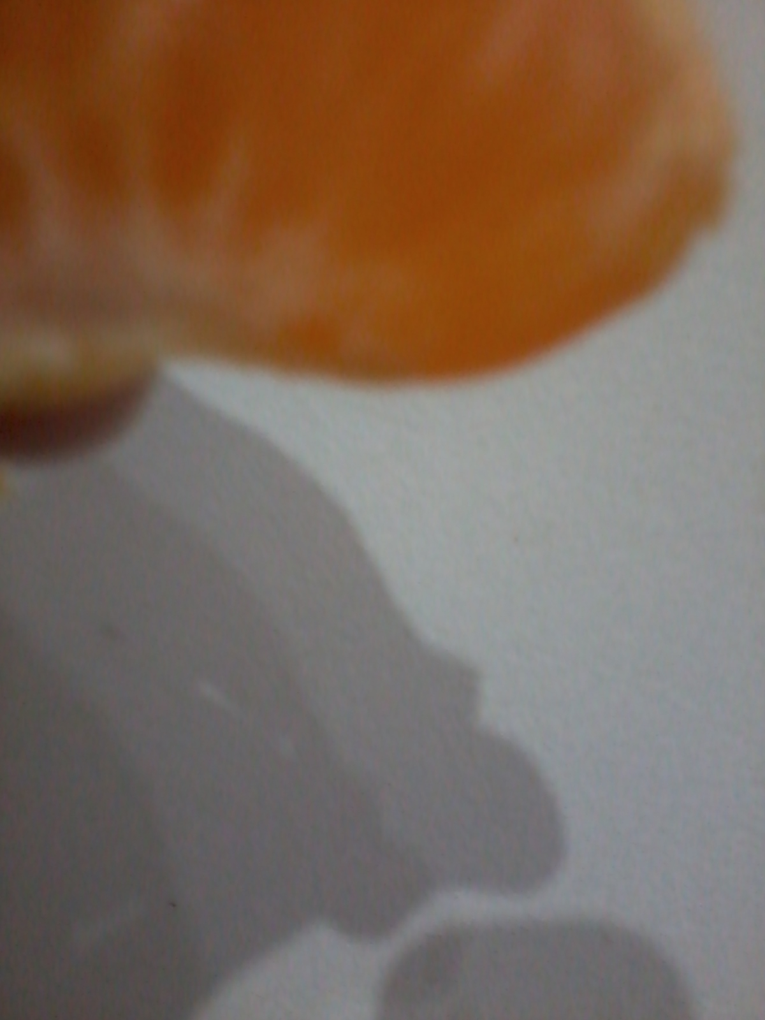

SEGMENT THREE
ALLAH’S NAME IS AT THE MIDDLE-CENTRE OF THE SEGMENT
[FOR PHOTOGRAPH, PLEASE SCROLL DOWN TO THE NEXT PAGE]

