THE EXCLUSIVE ISLAMIC MIRACLE PHOTOGRAPHS OF DR UMAR ELAHI AZAM – MISCELLANEOUS PHOTOGRAPHS OF 22-27 OCTOBER 2014
Manchester, UK
29 October 2014

Chilli sauce on my plate of chicken curry and rice naturally forming the Name of Allah Most High. This meal bought from New Shalimar Takeaway on Claremont Road, M16, UK on Monday 27 October 2014.

[Please scroll down to the next two pages]

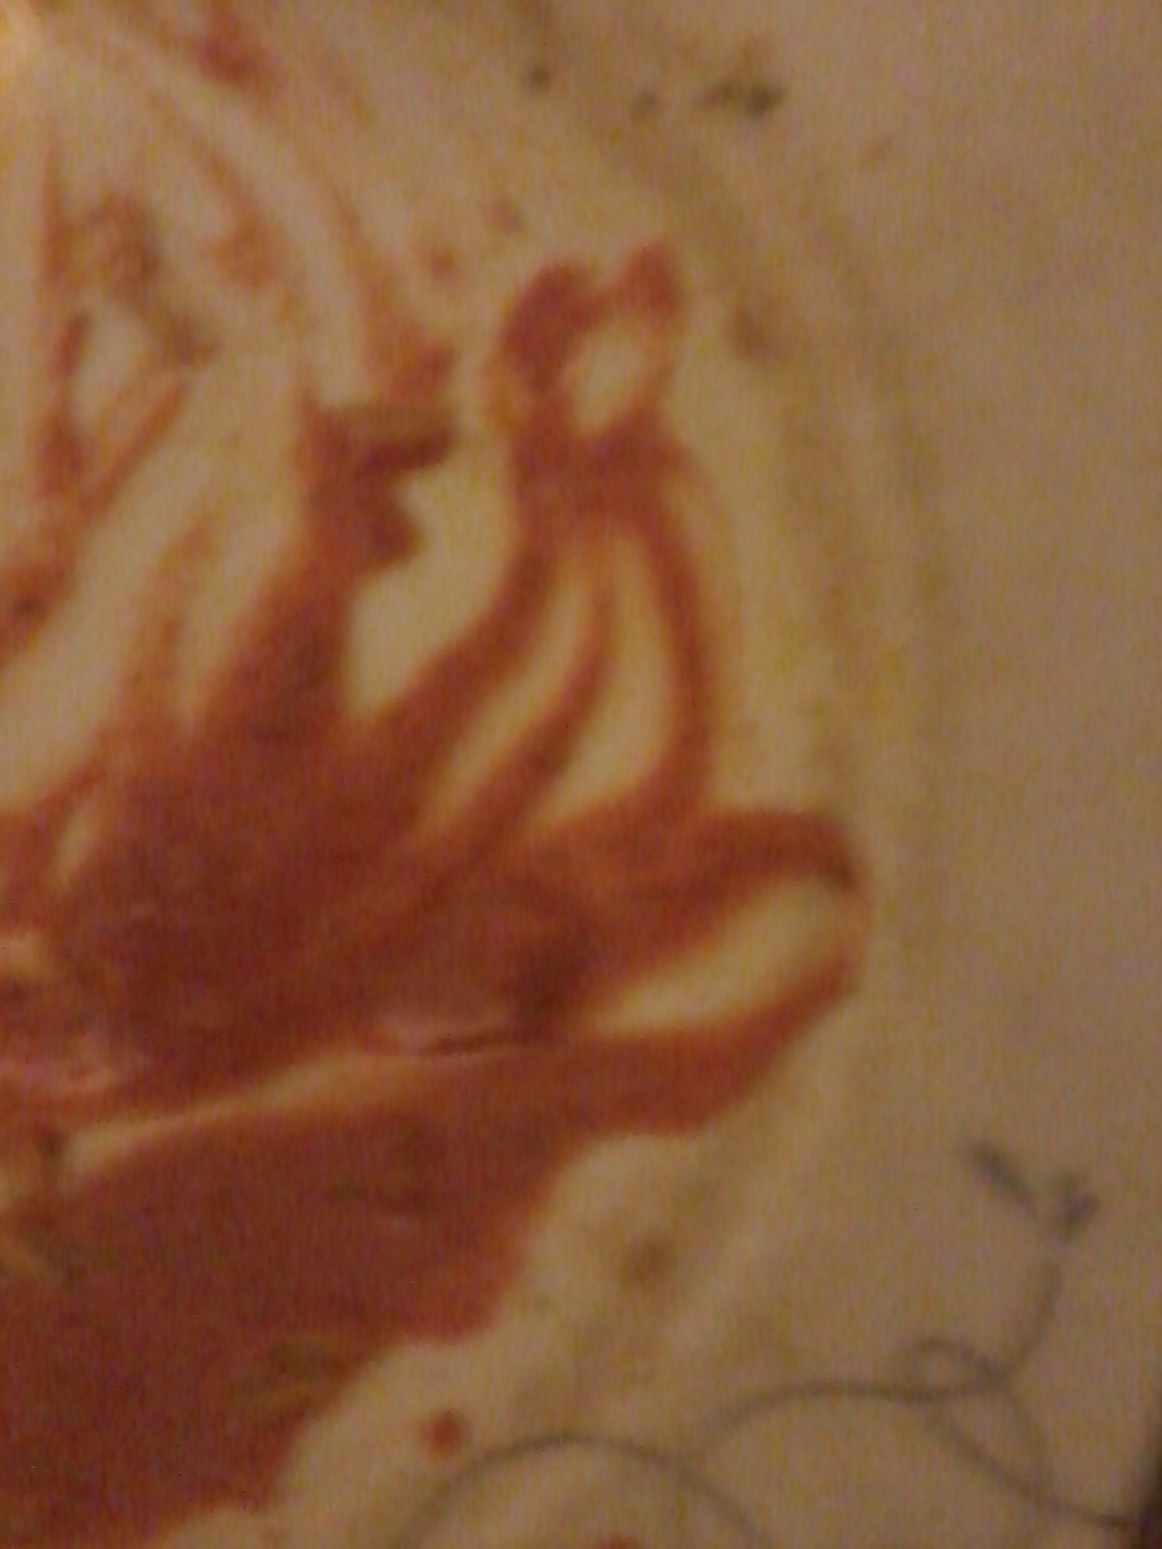
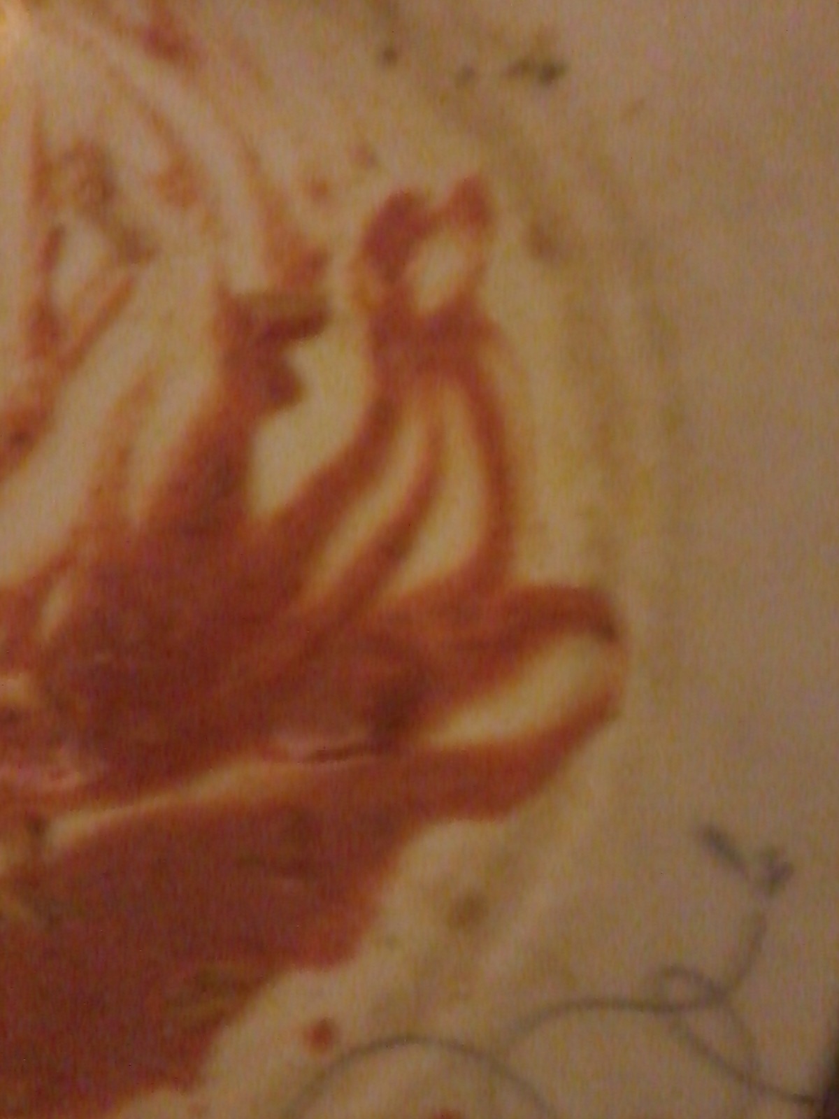

Allah’s Name on the inside peel of a pomegranate bought from Appna Exotic Food Superstore, Mitre Road M13, UK on Wednesday 22 October 2014.

[Please scroll down to the next two pages]

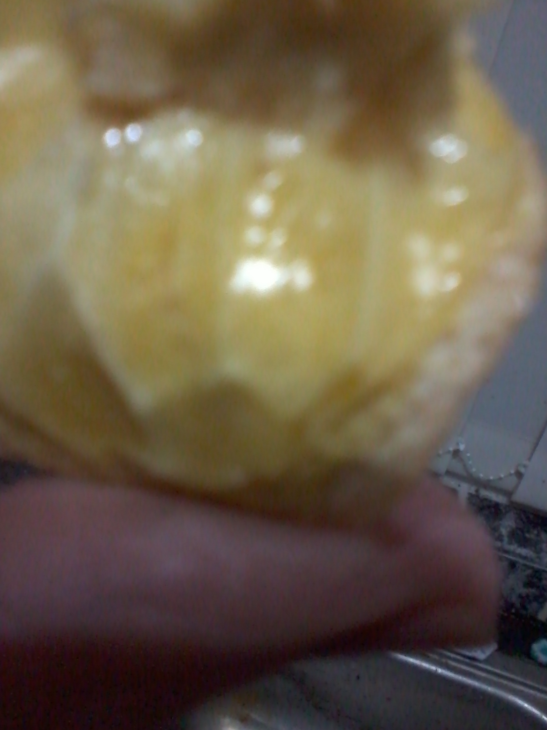
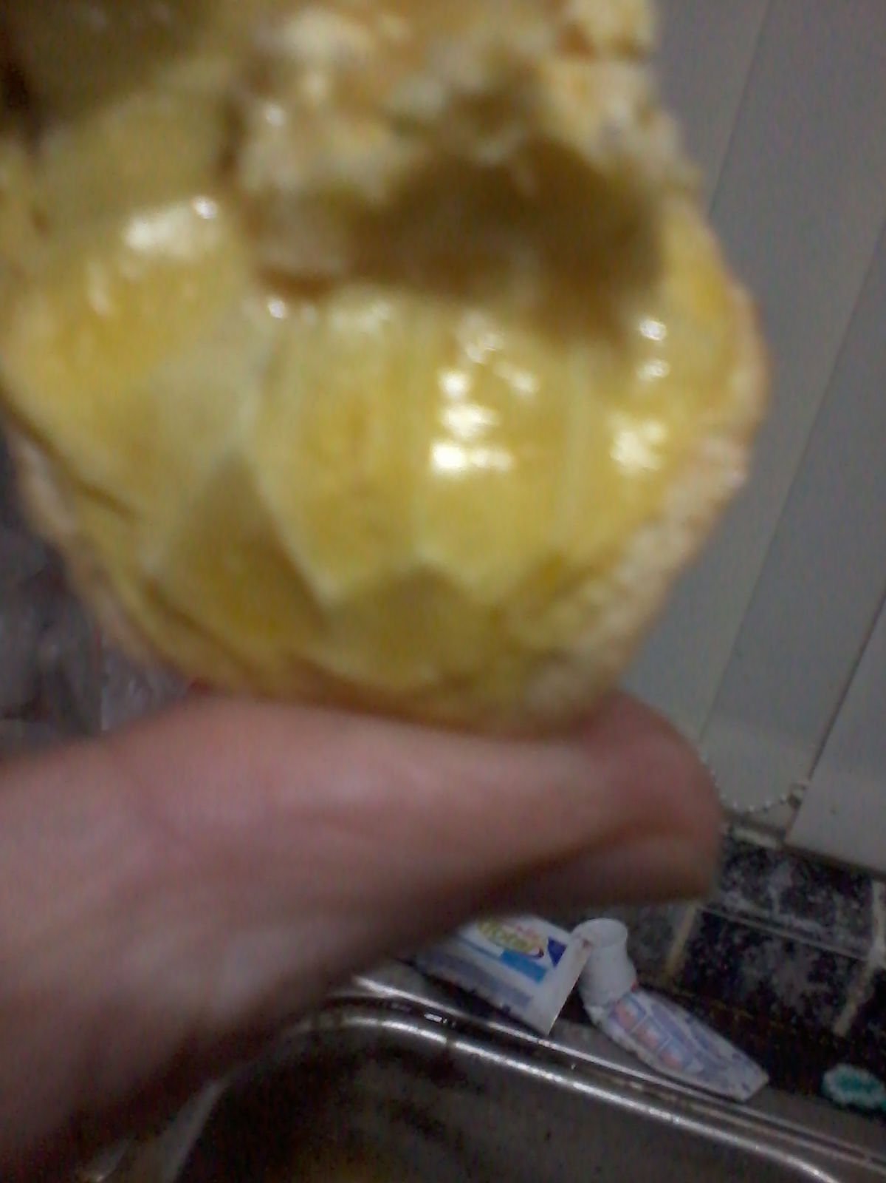

Part of a bunch, formerly holding a variety of red-and-white grapes, forming the Name of Allah Most High [even the shape of the letter ‘Ha’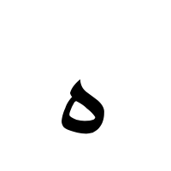of Allah may be seen at the end of the word. The grapes were bought from Worldwide Food Store, Wilmslow Road, M14, UK on Sunday 26 October 2014.

[Please scroll down to the next two pages]

