THE EXCLUSIVE MIRACLE PHOTOGRAPHS OF DR UMAR AZAM – MIRACLE TANGERINE
Manchester, UK
October 2014

Please scroll down to the next page
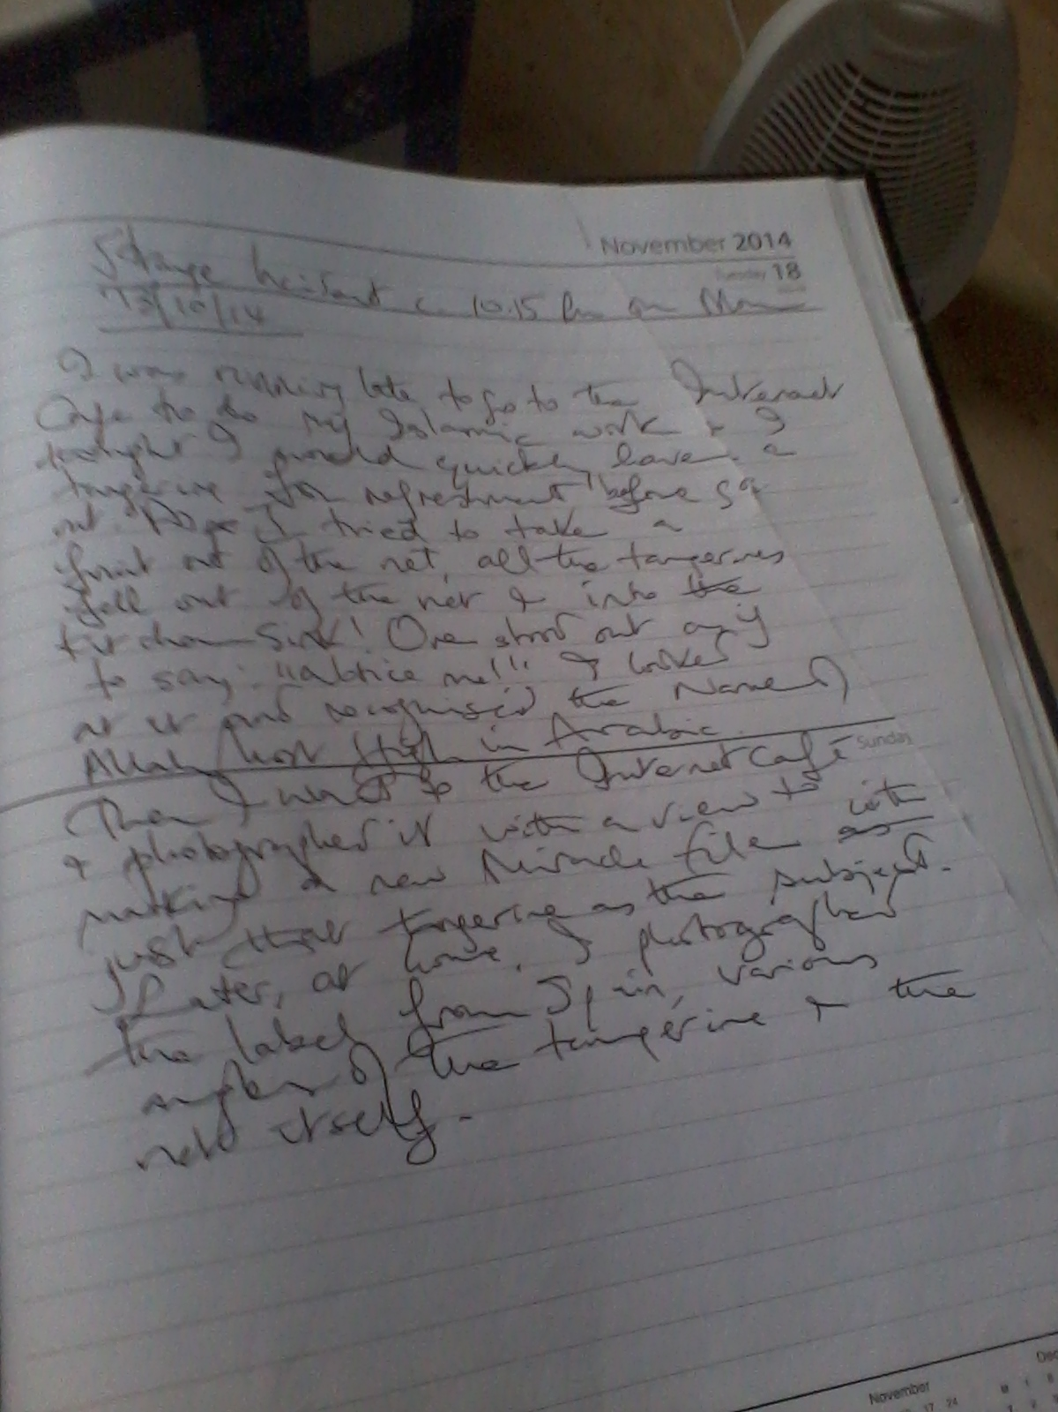

What does the text above state?

Strange Incident c. 10:15 pm on Monday 13/10/14
I was running late to go to the Internet Café to do my Islamic work and I thought I would quickly have a tangerine for refreshment before going out. As I tried to take a fruit out of the net, all the [remaining] tangerines fell out of their net and into the kitchen sink [from their place on the kitchen unit]. One stood out as if to say: ‘Notice me!’ I looked at it and recognised the Name of Allah Most High in Arabic. Then I went to the Internet Café and scanned the fruit with a view to making a new Miracle File with just this tangerine as the subject. Later, at home, I photographed the label from Spain, various angles of the tangerine and the net itself.
[The tangerines were bought from Manchester Superstore, Stockport Road, M13 UK on Saturday 11 October 2014.]
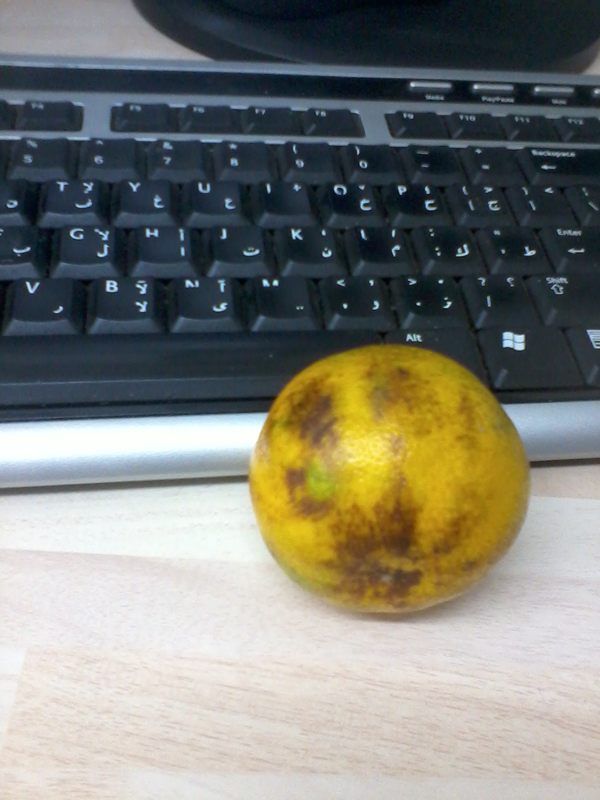

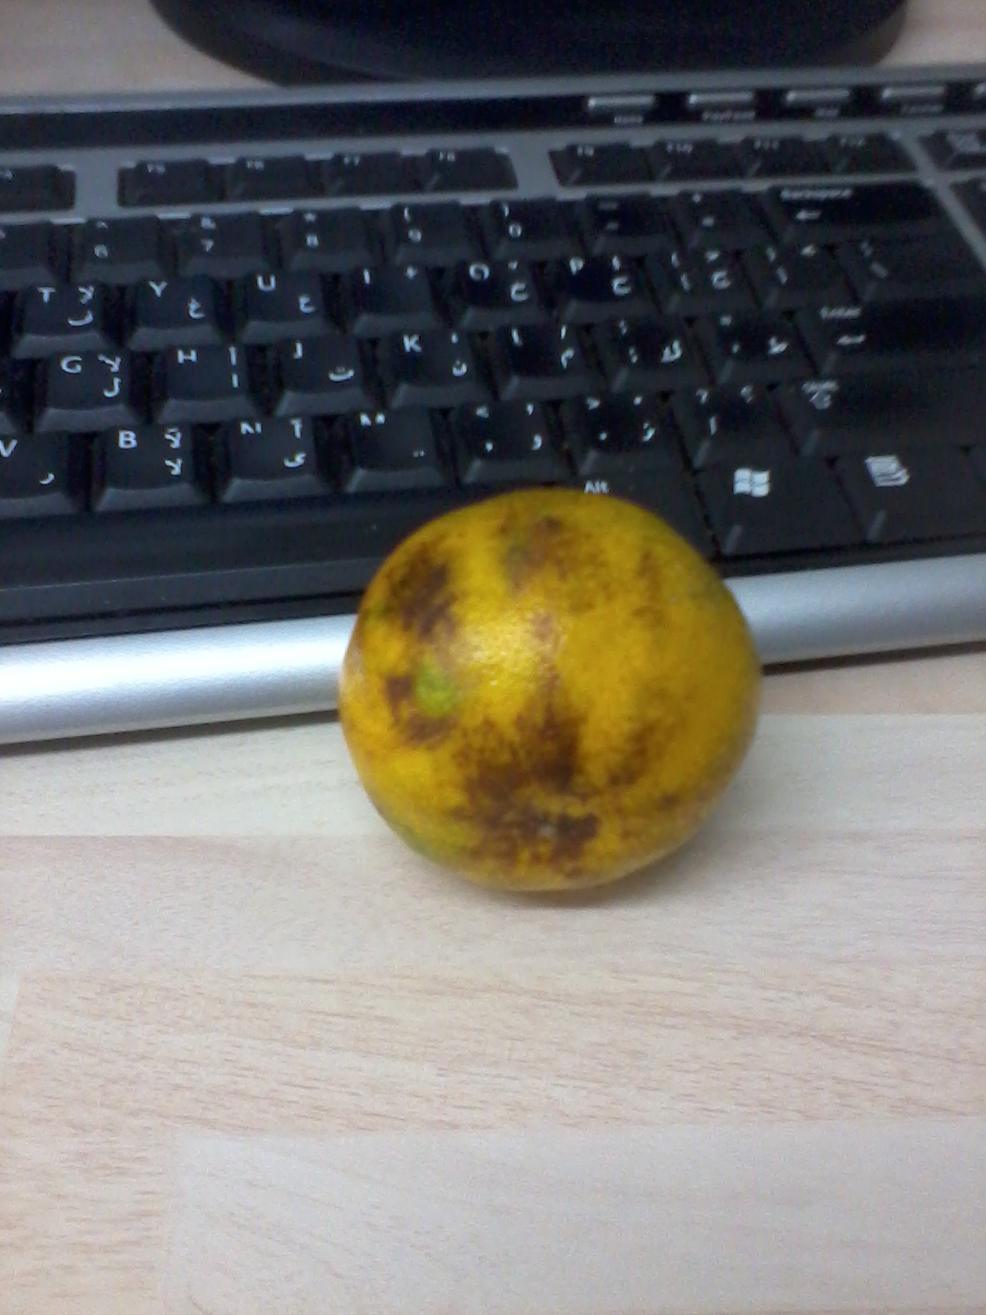
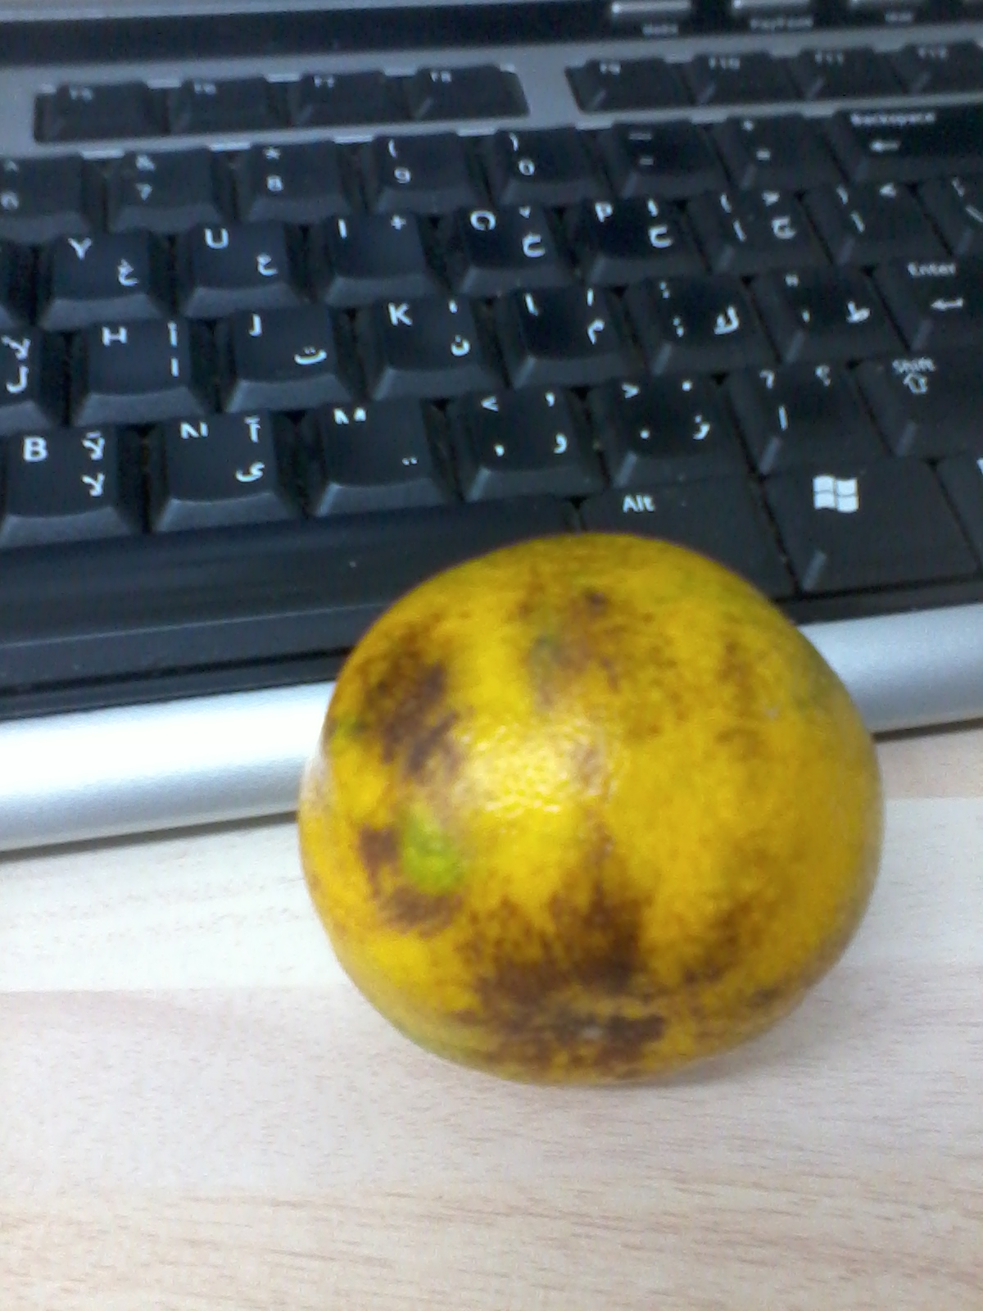
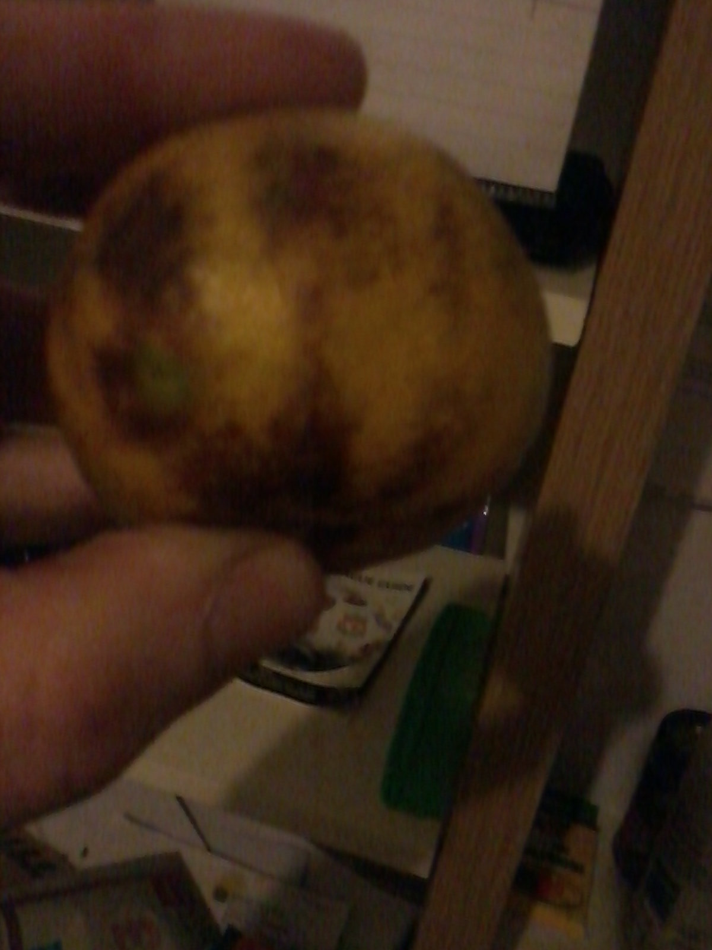
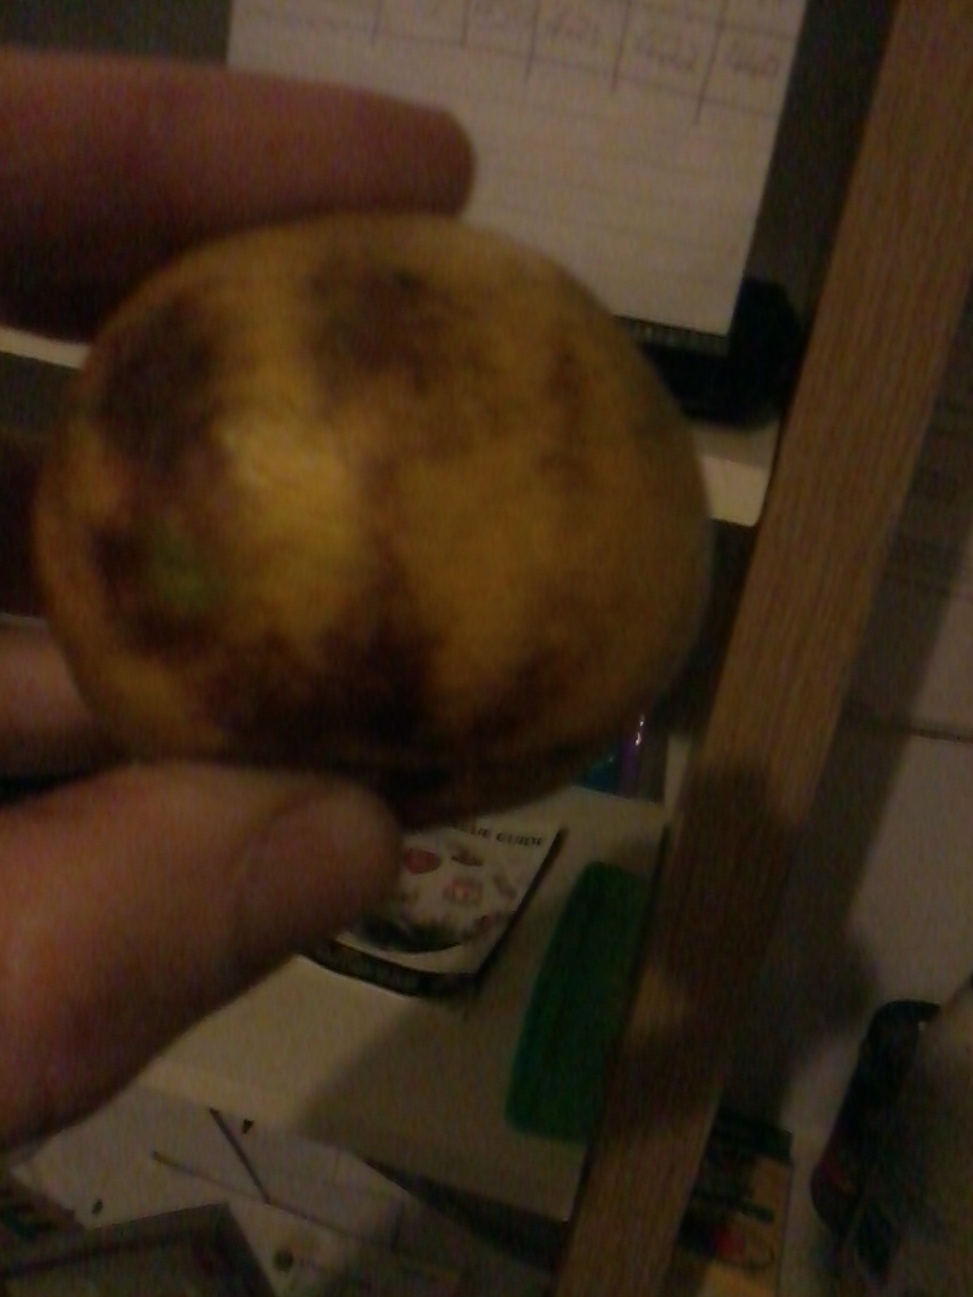
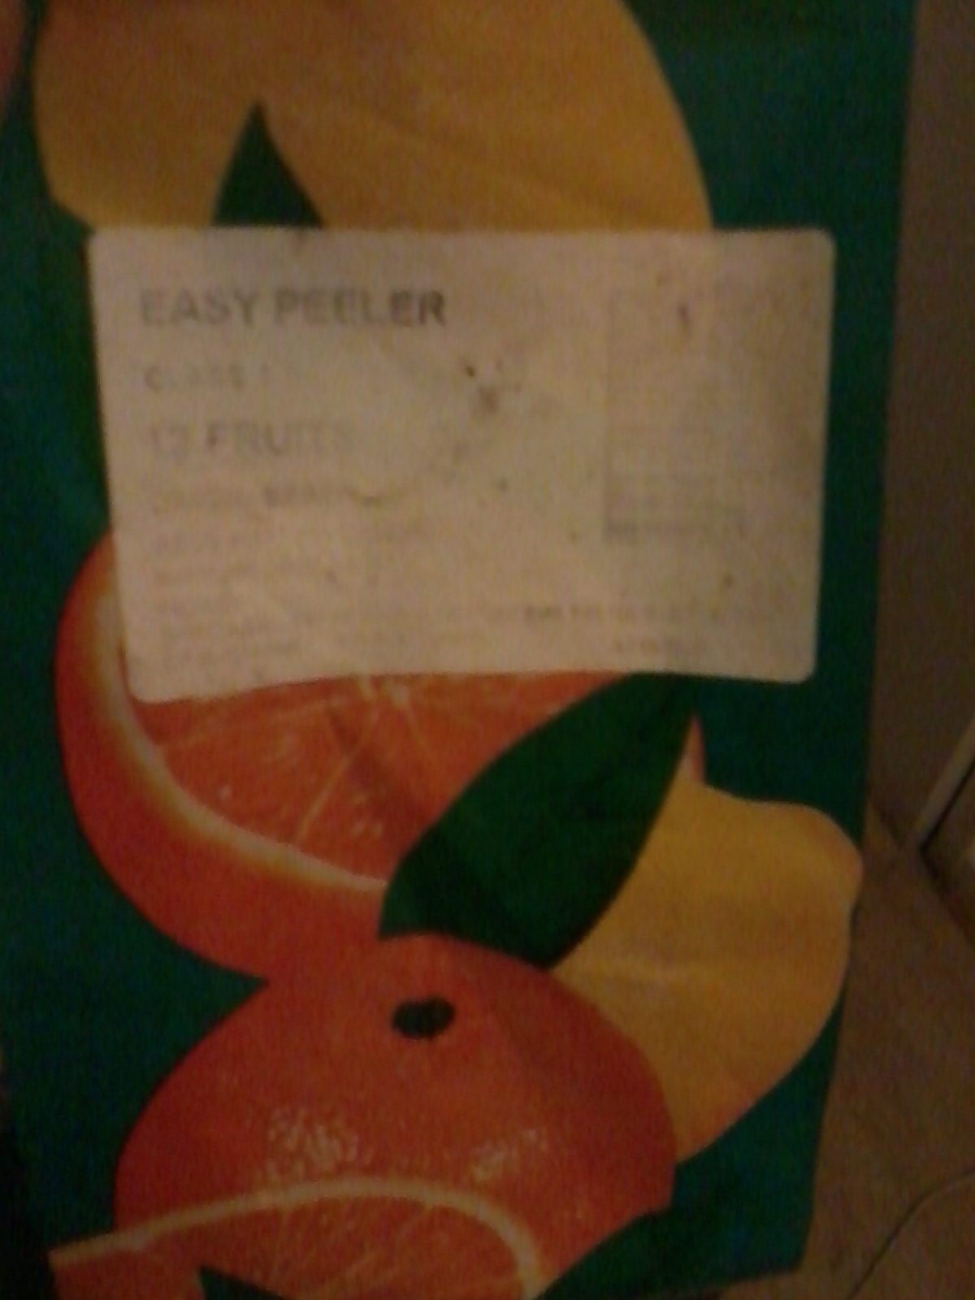
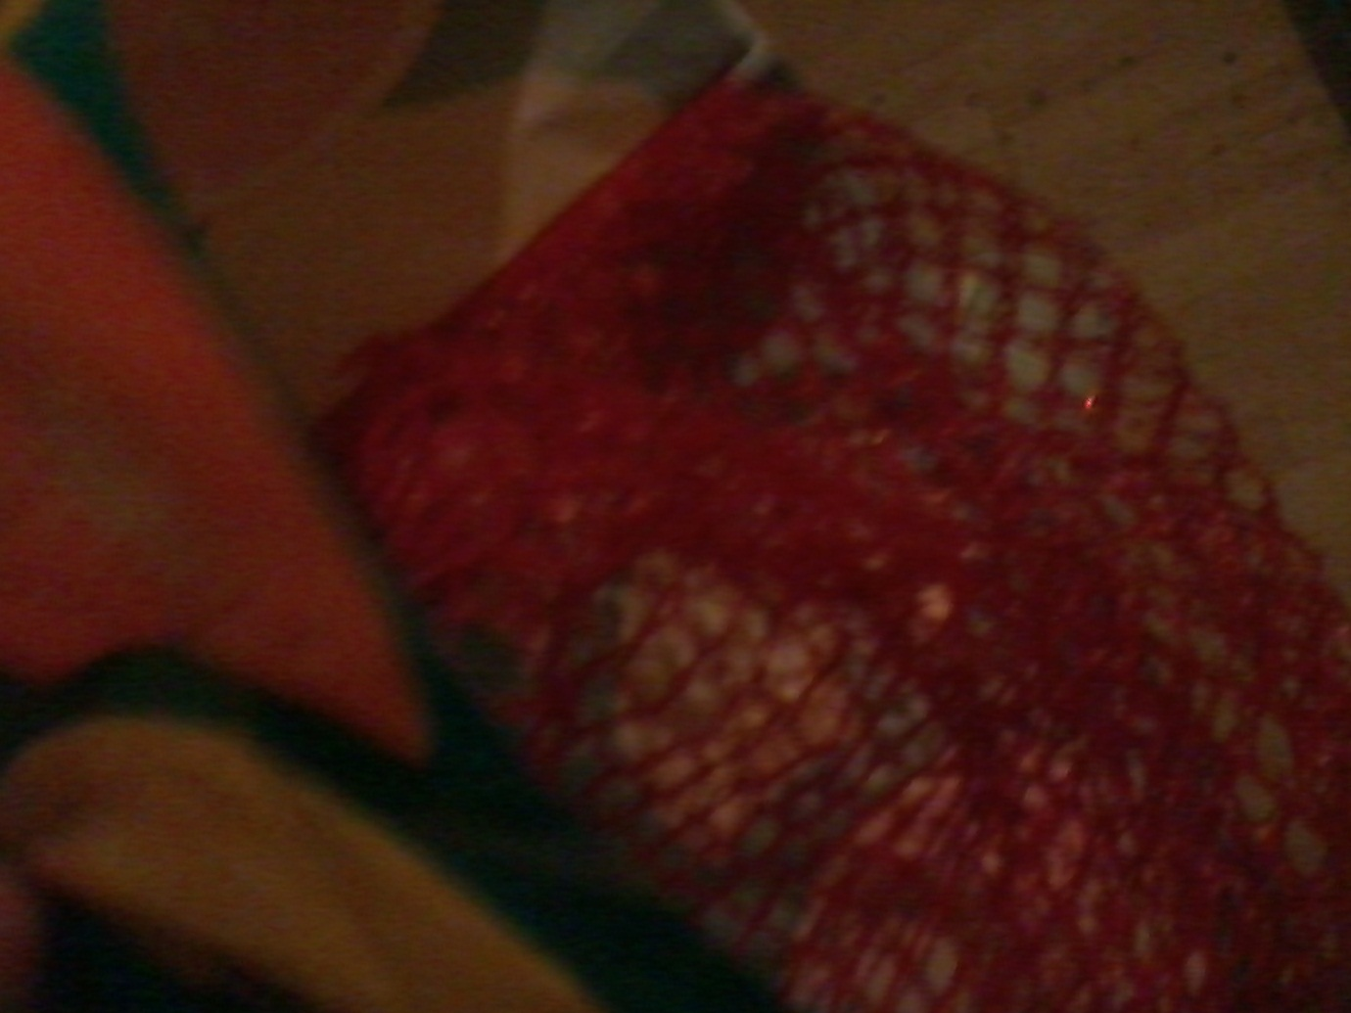

To see a scan of the Miracle Tangerine and indication to the Arabic letters OF THE Name of Allah on the outside of the fruit, please click the link below:
http://dr-umar-azam-blog.weebly.com/uploads/3/1/8/2/31826375/dr_omar_201410142248_1.pdf

