THE EXCLUSIVE MIRACLE PHOTOGRAPHS OF DR UMAR ELAHI AZAM – PHOTOGRAPHS OF MIRACLE PEAR OF 19/10/2014
MANCHESTER, UK

Before going to my 4.30 pm maths tuition lesson with a pupil named Ayesha, I just had a look to see the pears in the kitchen of my Dickenson Road lodgings. I did find a Miracle Pear! I saw one with the name of Muhammad S.A.W. on it, so I took 4 photographs of it to add to my collection of PDF Islamic Miracle Photographs exclusive to myself [a photograph or two may have been repeated below].
The pear was from a punnet of pears was bought from Appna Exotic Food Superstore, Mitre Road, M13 on Friday 17 October 2014.

[Please scroll down to the next page]
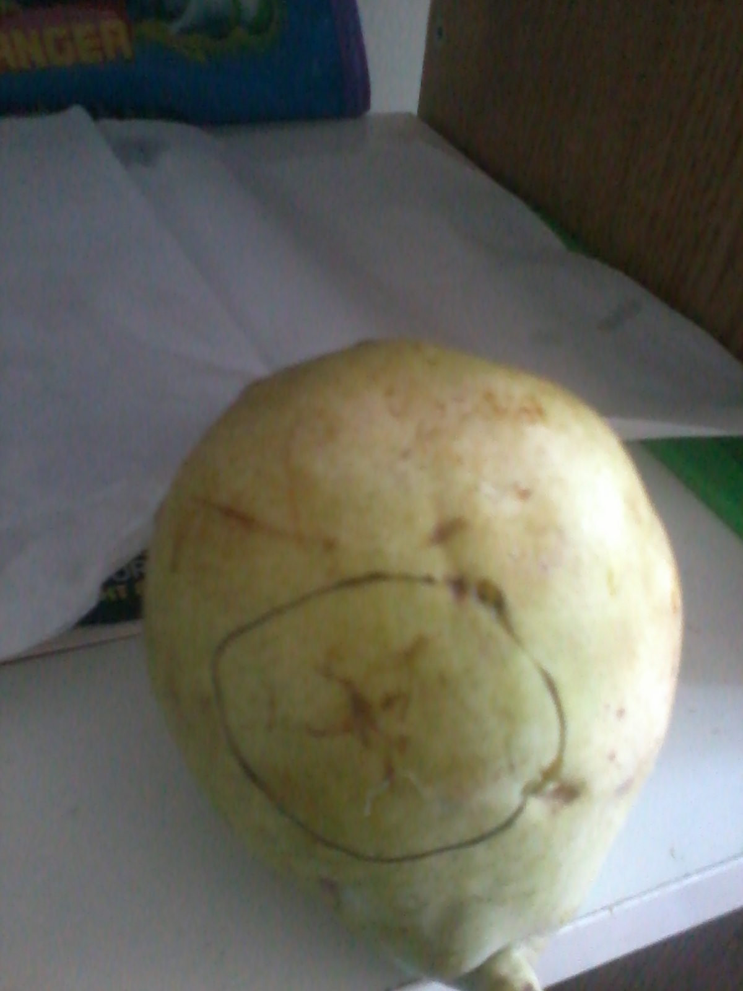
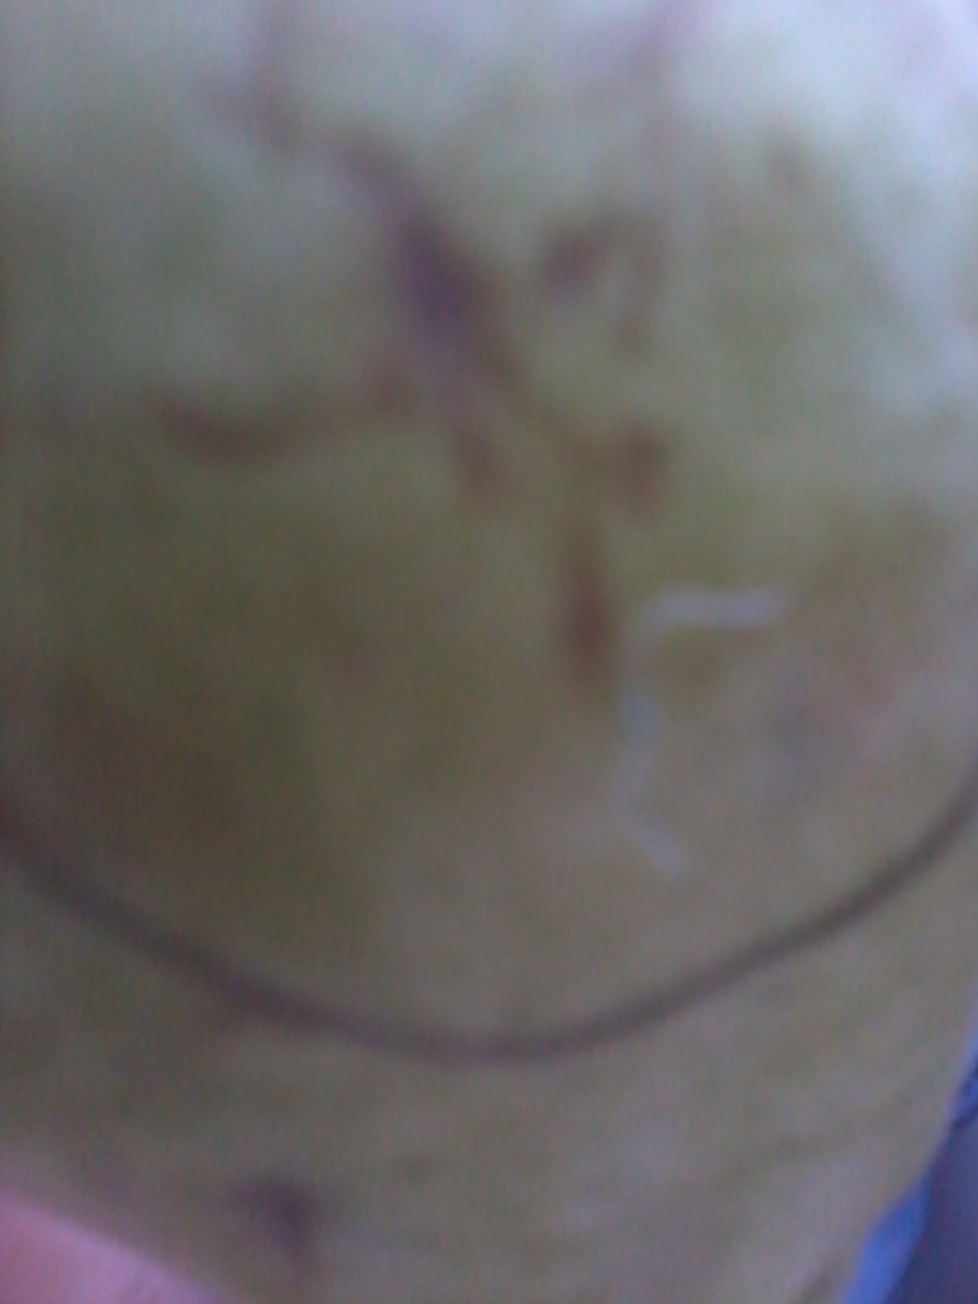
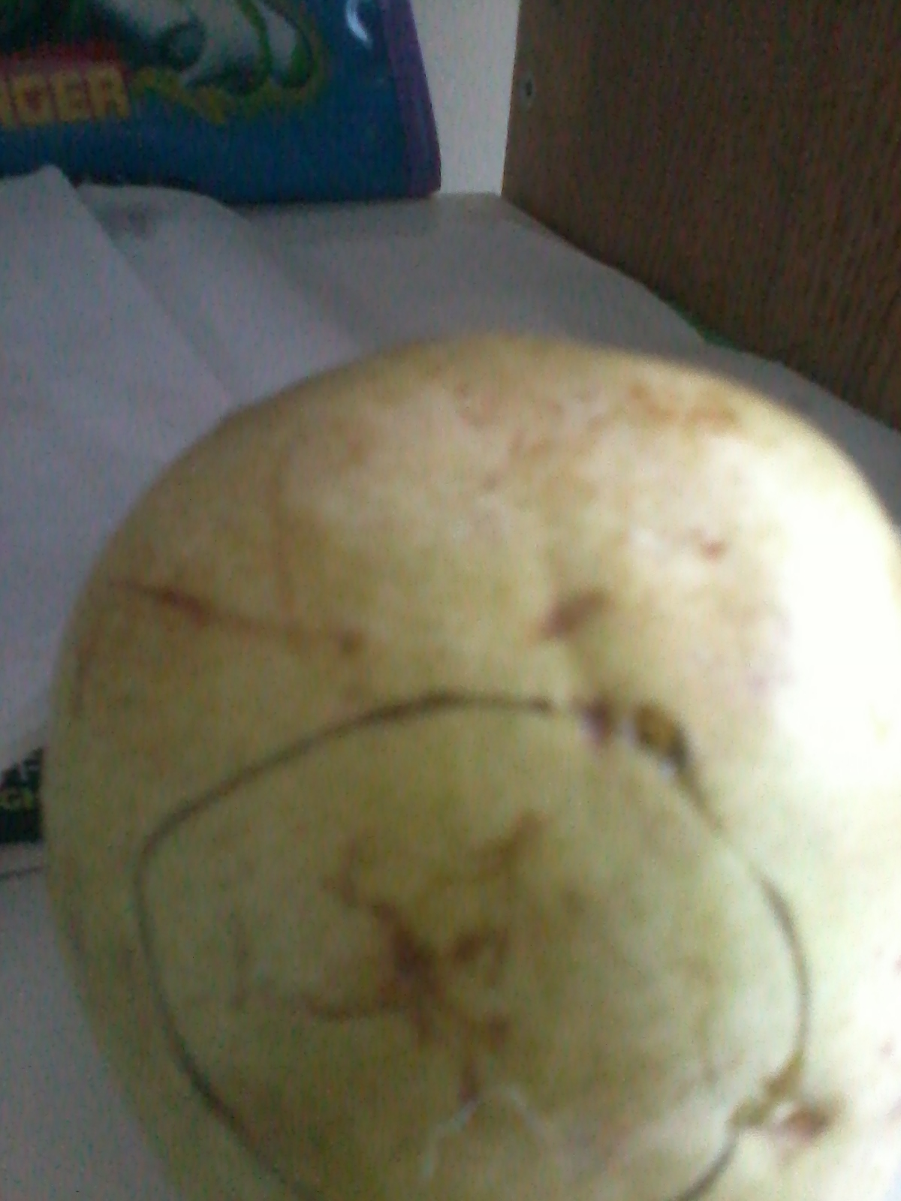

SCAN OF THE MIRACLE PEAR
The name of Muhammad S.A.W. can be vaguely made out in the left of the circle in the link of the scan below:

http://dr-umar-azam-blog.weebly.com/uploads/3/1/8/2/31826375/201410192156.pdf

